**PERSONAL ASSISTANCE FOR SENIORS WHO ARE SELF-RELIANT**

**1.INTRODUCTION**

**1.1 OVERVIEW**

The elderly people and the people victims of chronicle diseases who need to take the medicines timely without missing are suffering from dementia, which is forgetting things in their daily routine. Considering this situation, the technologies of home health care which are currently used for improving this situation by reminding the schedule of medicine and remote monitoring. It updates new medicine data of patients, which can be done by prescriber through web. It can be implemented with wireless module which should need to secure so that message containing the health-related information should not be corrupt. The benefit of digitally storing is the retrieving of data is easy and faster manner in case of emergency for secure health.

**1.2 PURPOSE**

Older adults who have difficulty with such daily activities as bathing, grooming, cooking, eating, or just getting to the bathroom often end up in hospitals or nursing homes, spending a disproportionately huge number of healthcare dollars, according to a report conducted for the U.S. Department of Health & Human Services. For far less money, perhaps 80 percent of these same elders could be made more self-reliant and healthy and also less depressed.

**2. LITERATURE SURVEY**

* 1. Existing problem
  2. References
  3. Problem Statement Definition

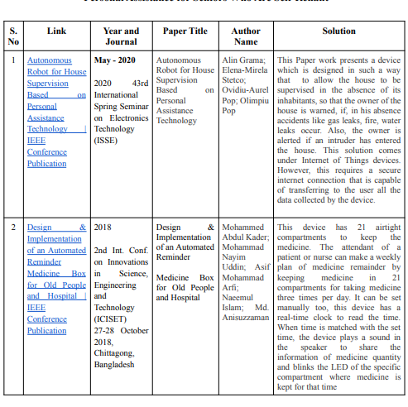

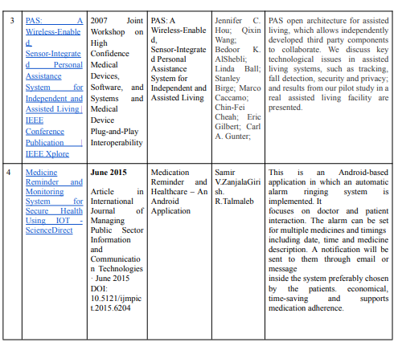

Problem Statement Definition

1. Sudha, the only daughter of their parents, was taking care of them since they were aged and affected by heart problems. Suddenly, she got an offer from her office to go abroad. Since she will not be able to stay with them ,how will she be able to look after them?

Develop a product or a prototype that could take care of their health, providing medicine periodically.

1. Vimal is celebrity fame who loves his daddy so much, his father has high blood pressure and his is a diabetic. Before Vimal’s celebrity life, he was the one who take cares of his father, now he has no time to look after his father.

Design a systematic tool to help vimal.

**3.** **IDEATION & PROPOSED SOLUTION**

**3.1 EMPATHY MAP CANVAS**

Project team shall fill the following information in proposed solute

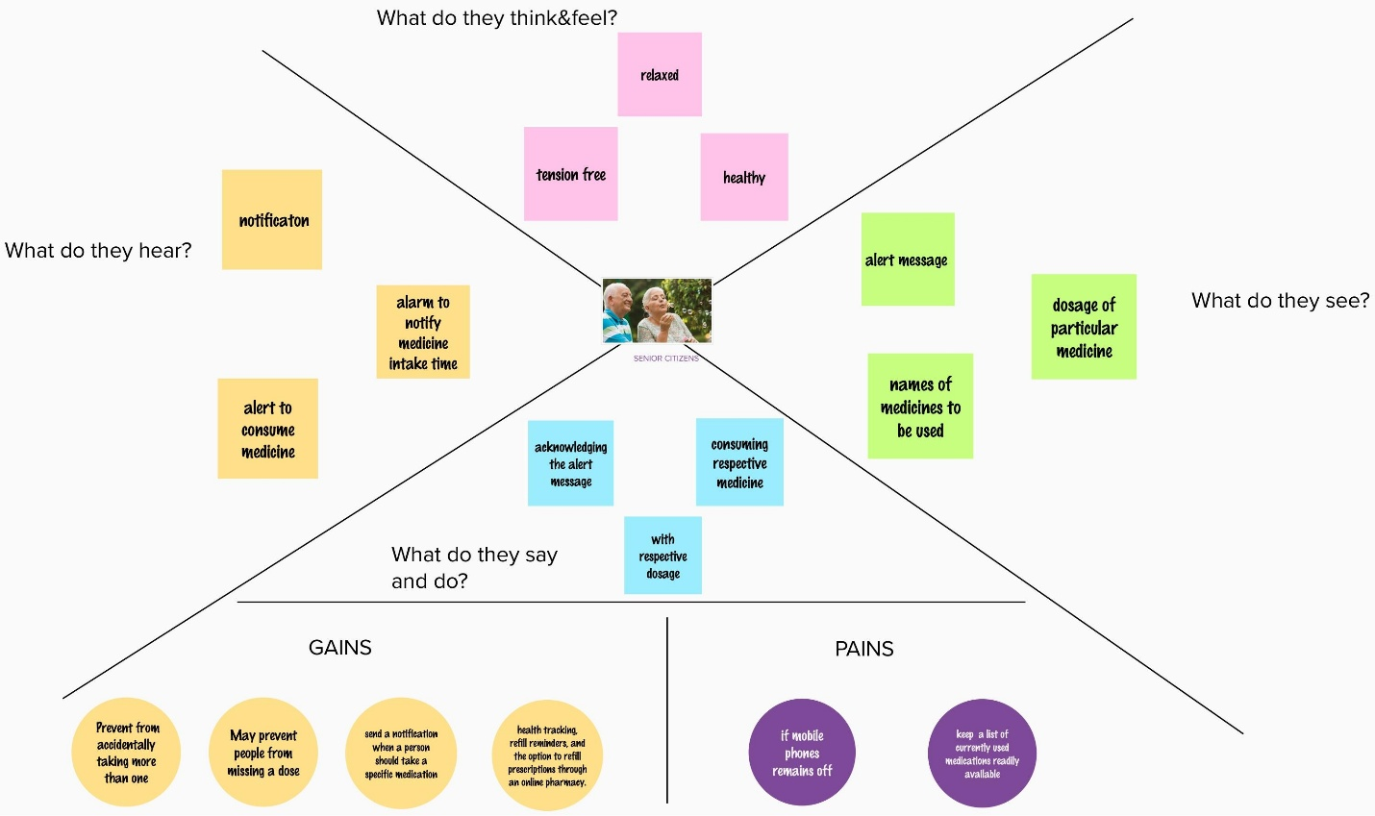on template.

**3.2 IDEATION & BRAINSTORMING**

**Step-1: Team Gathering, Collaboration and Select the Problem Statement**

**Brainstorm & Idea Prioritization Template:**

Brainstorming provides a free and open environment that encourages everyone within a team to participate in the creative thinking process that leads to problem solving. Prioritizing volume over value, out-of-the-box ideas are welcome and built upon, and all participants are encouraged to collaborate, helping each other develop a rich amount of creative solutions.

Use this template in your own brainstorming sessions so your team can unleash their imagination and start shaping concepts even if you're not sitting in the same room.

Reference: <https://www.mural.co/templates/empathy-map-canvas>

**Step-1: Team Gathering, Collaboration and Select the Problem Statement**

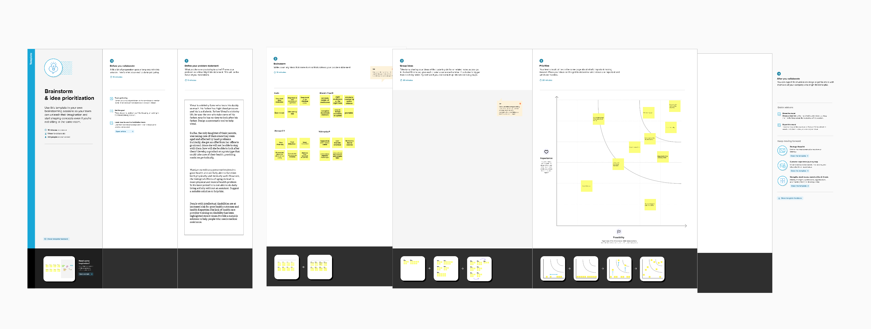

**Step-2: Brainstorm, Idea Listing and Grouping**

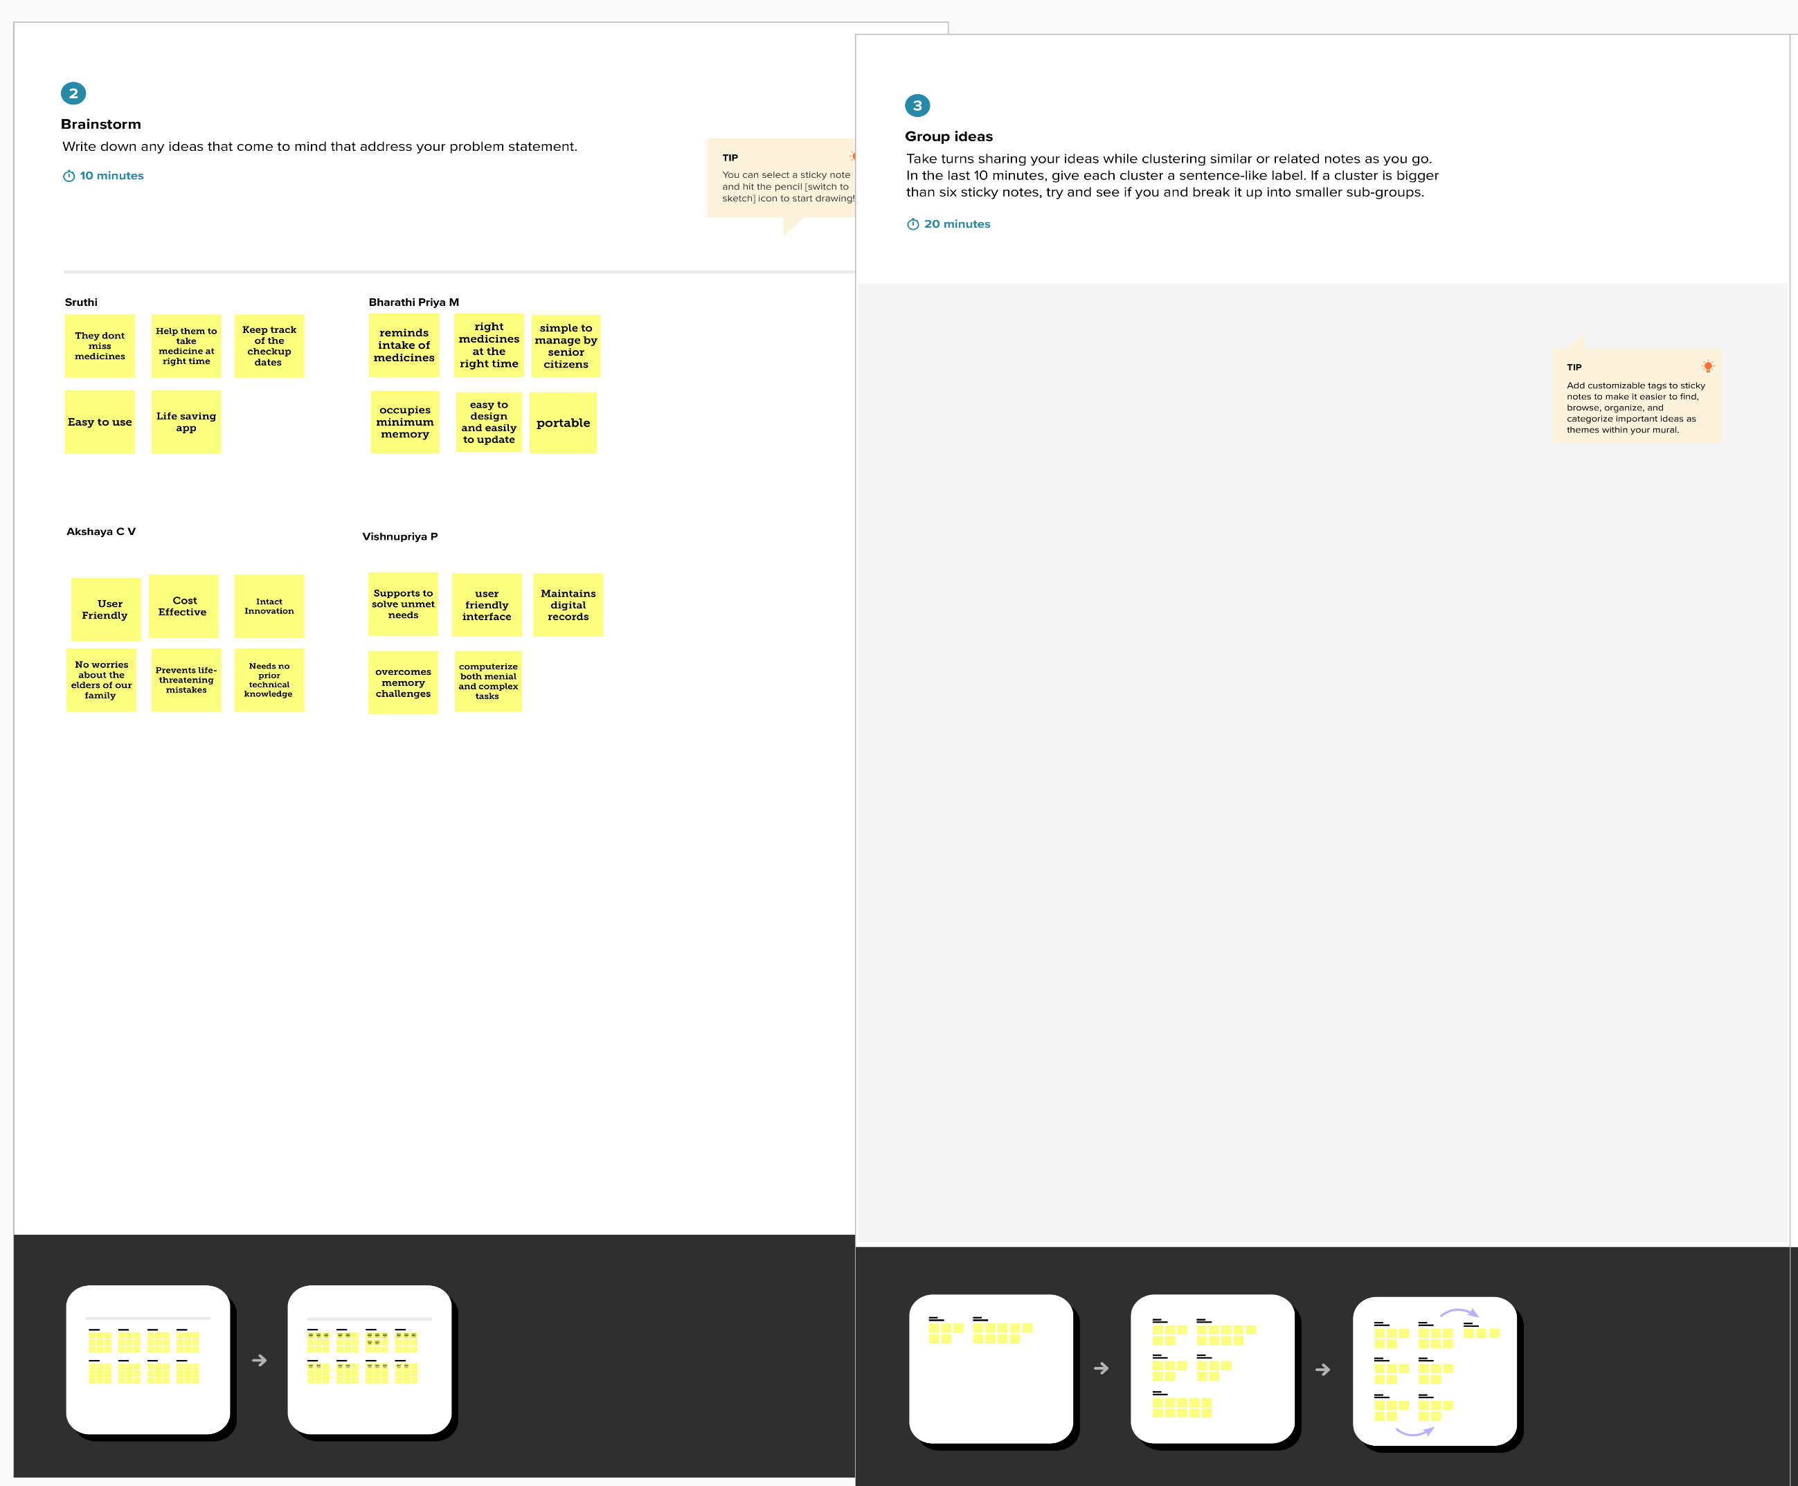

**Step-3: Idea Prioritization**

**3.3 PROPOSED SOLUTION**

|  |  |  |
| --- | --- | --- |
| **S.No.** | **Parameter** | **Description** |
| 1. | Problem Statement (Problem to be solved) | Develop a prototype that could help senior citizens to maintain their health by assisting them in their medication process. |
| 2. | Idea / Solution description | The elderly people and the people victims of chronicle diseases who need to take the medicines timely without missing are suffering from dementia, which is forgetting things in their daily routine. Considering this situation the technologies of home health care which are currently used for improving this situation by reminding the schedule of medicine and remote monitoring. |
| 3. | Novelty / Uniqueness | Update new medicine data of patients, which can be done by prescriber through web. |
| 4. | Social Impact / Customer Satisfaction | Assists customers in a regular basis with every prescribed medicine details such as the time ,dosage etc.which helps them take proper medicine in the right time with definite accuracy,and eventually leading to good health. |
| 5. | Business Model (Revenue Model) | Can be implemented with wireless module which should need to secure so that message containing the health related information should not be corrupt.The benefit of digitally storing is the retrieving of data is easy and  faster manner in case of emergency for secure health |
| 6. | Scalability of the Solution | As it is a developed application,it is user friendly and of low cost.Any new updates can be given shortly. |

**3.4 PROBLEM SOLUTION FIT**

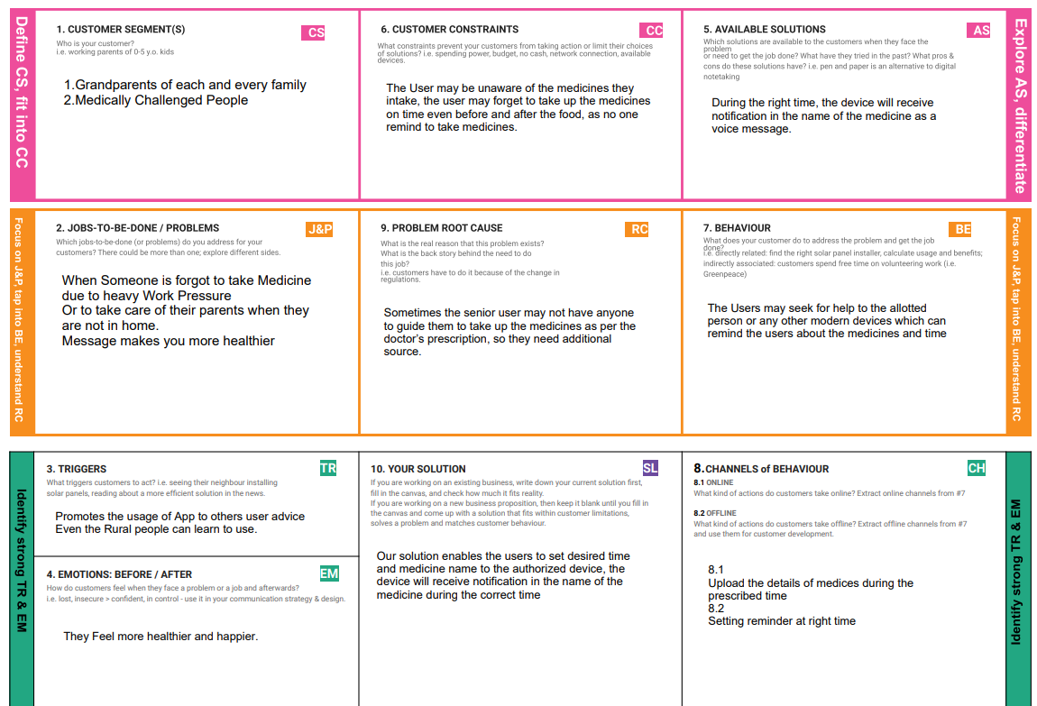

**4.REQUIREMENT ANALYSIS**

**Functional Requirements:**

Following are the functional requirements of the proposed solution.

|  |  |  |
| --- | --- | --- |
| **FR No.** | **Functional Requirement (Epic)** | **Sub Requirement (Story / Sub-Task)** |
| FR-1 | User Registration | Voice Commands  Reminders  Software IDLE |
| FR-2 | User Registration | Manual  Through Webpage,  Forms and  Gmail |
| FR-3 | User Confirmation | Via Phone call  Gmail and OTP |
| FR-4 | Payment Options | Cash on Delivery  UPI  Cards  Net/Banking |
| FR-5 | Product Delivery and Installation | Take away  Delivery  Installation is free of cost |
| FR-6 | Product Feedback | Through Webpage |

**Non-functional Requirements:**

Following are the non-functional requirements of the proposed solution.

|  |  |  |
| --- | --- | --- |
| **FR No.** | **Non-Functional Requirement** | **Description** |
| NFR-1 | **Usability** | Reminds during the specified time User Friendly |
| NFR-2 | **Security** | The App has to be secured wit two step verification, Passwords and Passkeys are must.  Fingerprints and Face Recognition are also must. |
| NFR-3 | **Reliability** | The Hardware needs to be checked on a regular basis, softwares should be updated periodically, Immediate alert must be send in case of any failuers |
| NFR-4 | **Performance** | Should have good user interface, and should have a battery consumption, it has to save energy |
| NFR-5 | **Availability** | All the features will be available when the user requires, and it depends on the need of the users. |
| NFR-6 | **Scalability** | It maintains a proper health condition and provides good mental state |

**5.PROJECT DESIGN**

**Solution Architecture Diagram:**

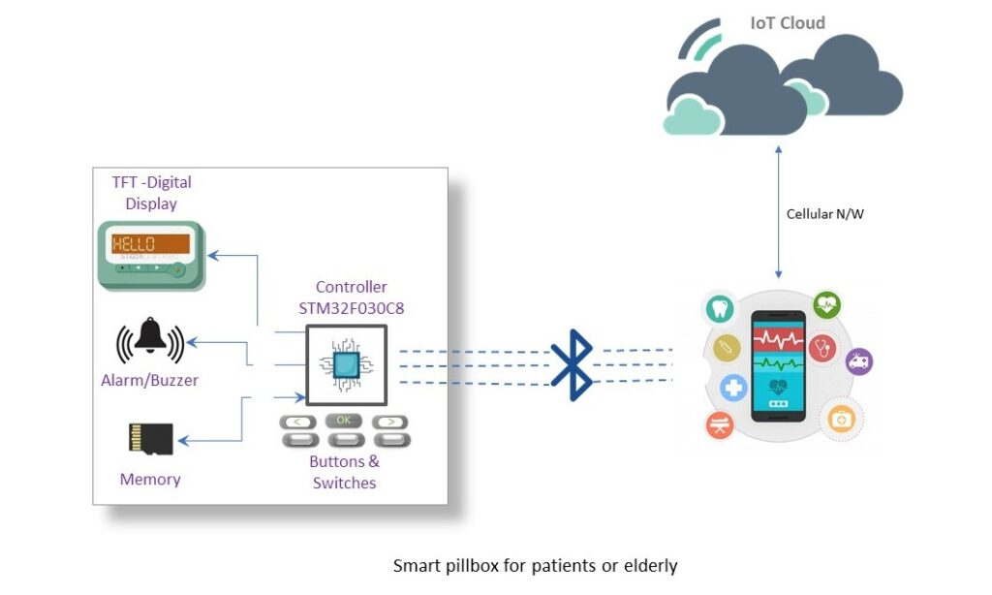

Figure 1: Architecture and data flow of the personal assistant sample application

This architecture shows the working of the system. A medicine reminder app that manages prescription schedules and alerts for reminding patients about the type and time of the medication according to the prescribed medicine schedule. Sometimes elderly people forget to take the medicine at the correct time. They also forget which medicine He / She should take at that particular time.And it is difficult for doctors/caretakers to monitor the patients around the clock. To avoid this problem, this medicine reminder system is developed.

**Methodologies :**

An app is built for the user (caretaker) which enables him to set the desired time and medicine. These details will be stored in the IBM Cloudant DB. if the medicine time arrives the web application will send the medicine name to the IoT Device through the IBM IoT platform. The device will receive the medicine name and notify the user with voice commands.

**Algorithm:**

**Step 1:**

**Future scope and Conclusion:**

The installation of an Internet of Things (IoT) device that provides a comprehensive solution for independent seniors. A novel idea is to put in place an automated system that will remind seniors with medical conditions to take their medications on time and will also keep track of their health problems. For elders, this idea suggests a Smart IoT personal assistant that can also help with remote monitoring.

**6. PROJECT PLANNING & SCHEDULING**

|  |  |  |  |  |  |  |  |  |  |  |  |  |
| --- | --- | --- | --- | --- | --- | --- | --- | --- | --- | --- | --- | --- |
| **Sprint** | | **Functional**  **Requirement (Epic)** | | **User Story Number** | | **User Story / Task** | | **Story Points** | **Priority** | | | **Team Members** |
| Sprint-1 | | Registration | | USN-1 | | As a user, I can register for the application by  entering my email, and password, and confirming my password. | | 3 | High | | | Sruthi S |
| Sprint-1 | | Confirmation Email | | USN-2 | | As a user, I will receive a confirmation email once I have registered for the application | | 4 | High | | | Akshaya C V |
| Sprint-1 | | Authentication | | USN-3 | | As a user, I can register for the application through Gmail and mobile app. | | 4 | Medium | | | Bharati Priya M |
| Sprint-1 | | Login | | USN-4 | | As a user, I can log into the application by entering email & password | | 3 | High | | | Bharati Priya M |
| Sprint-1 | | Dashboard | | USN-5 | | As a user, I need to be able to view the functions that I can perform | | 4 | High | | | Sruthi S |
| Sprint-2 | | Notification | | USN-1 | | As a user, I should be able to notify my parent and guardian in emergency situations | | 1  0 | High | | | Akshaya C V |
| Sprint-2 | | Store data | | USN-2 | | As a user, I need to continuously store my location data into the database. | | 1  0 | Medium | | | Akshaya C V |
| Sprint-3 | | Communication | | USN-3,1 | | I should be able to communicate with user | | 6 | Low | | | Vishnu Priya P |
| **Sprint** | **Functional**  **Requirement (Epic)** | | **User Story Number** | | **User Story / Task** | | **Story Points** | | | **Priority** | **Team Members** | |
| Sprint-3 | IoT Device – Watson communication | | USN-1,4 | | The data from IoT device should reach IBM Cloud | | 7 | | | Medium | Sruthi S | |
| Sprint-3 | Node RED - Cloudant DB communication | | USN-5,2 | | The data stored in IBM Cloud should be properly integrated with Cloudant DB | | 7 | | | High | Bharathi Priya M, Akshaya C V | |
| Sprint-4 | User – Web UI interface | | USN-1,4 | | The Web UI should get inputs from the user | | 6 | | | High | Sruthi S, Akshaya C V | |
| Sprint-4 | Alarm | | USN-2,3,5 | | The Alarm of the remainder should be done based on the medication time | | 7 | | | High | Vishnu Priya, Sruthi S | |

**7. CODING & SOLUTIONING**

**7.1. Feature 1**

* IoT Device
* IBM Watson platform
* Node - Red
* Cloudant DB
* Web UI
* MIT App Inventor
* Python Code

**7.2. Feature 2**

* Login
* Working

**8. TESTING**

**8.1. Test Cases**

This report shows the number of test cases that have passed, failed, and untested.

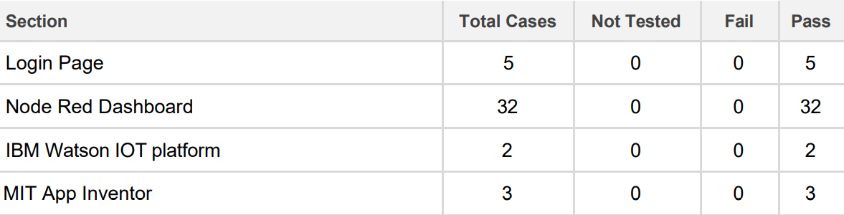

**Test Case 1:**

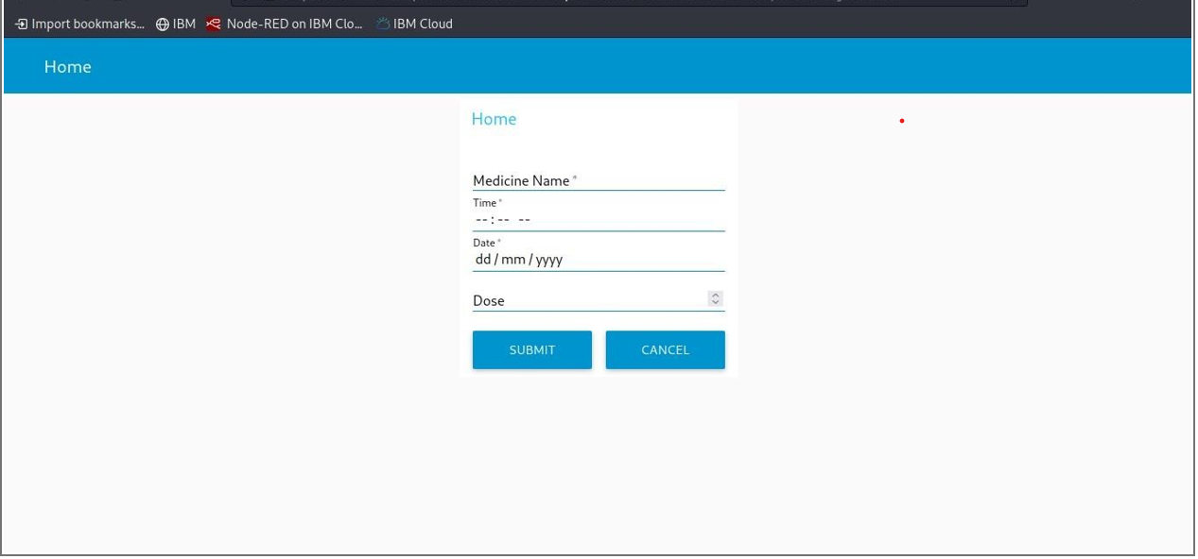

**8.2. User Acceptance Testing**

The main Purpose of UAT is to validate end to end business flow. It does not focus on cosmetic errors, spelling mistakes or system testing. User Acceptance Testing is carried out in a separate testing environment with production-like data setup. It is kind of black box testing where two or more end-users will be involved.

                    UAT is performed by :

                                            • Client

                                            • End user

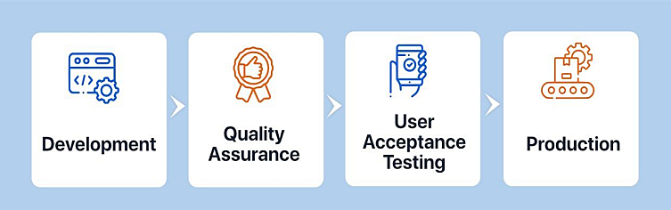

**Defect Analysis**

This report shows the number of resolved or closed bugs at each severity level, and how they were resolved.

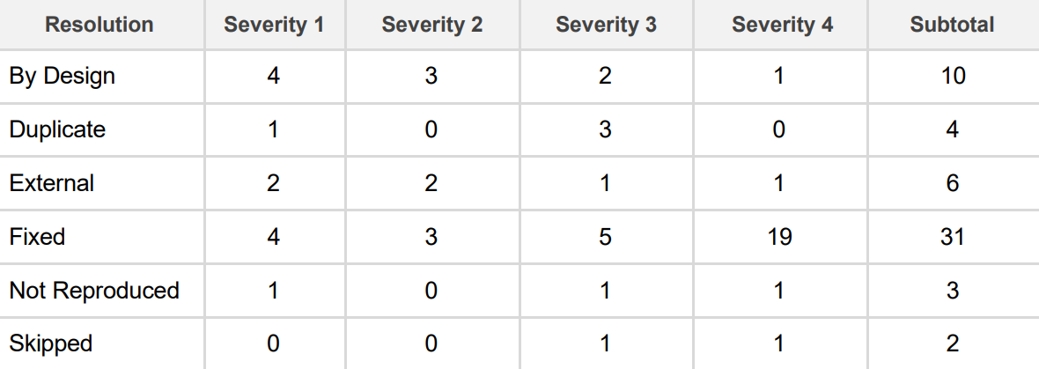

**9. RESULTS**

**9.1. Performance Metrics**

An experiment is conducted on an elderly person who is in need of Personal Assistant Device and the following results are obtained, it shows the medicine reminder that gives the information regarding the intake of medicine by the person using the personal Assistant Device. The stored data in cloudant database on specified time alerts user with a voice message.

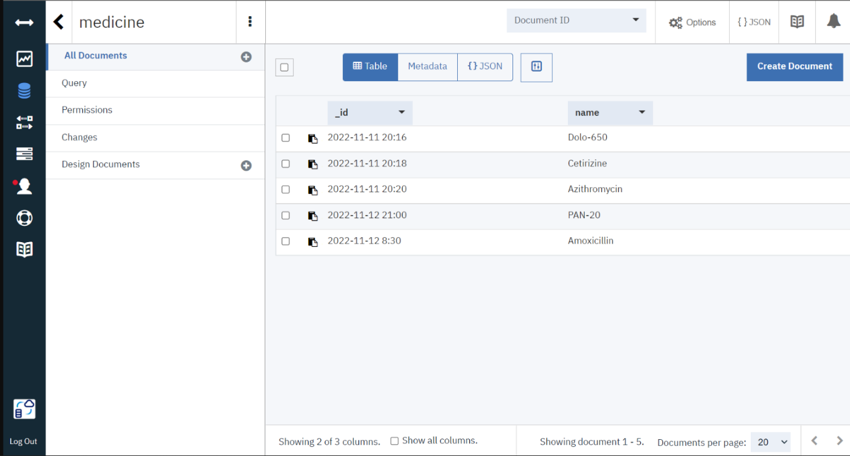

**10. ADVANTAGES & DISADVANTAGES**

**ADVANTAGES**

* Availability

One of the primary preferences of possessing a PDA is the capacity to stay in contact with individuals through email, text informing and telephone. Since PDAs are so convenient and networks so broad, clients can take them anyplace.

* Association

Another advantage of possessing a PDA is expanded association. Schedule and rundown applications make it simple to monitor arrangements, make notes in a hurry and document past discussions or other information.

* Status

For some PDA clients, the gadget has the additional advantage of meaning a specific status. Organization gave PDAs might be held for more significant level representatives and can come to connote a place of power or significance. For individual clients, having the most recent PDA might be an indication of riches or innovative information.

* Broad Internet Connectivity

For occupied people, the primary preferred position of getting a PDA is being able to remain associated through email, calls, text informing and different courier applications. These are worked with broad organization network so clients can get to the Internet anyplace they are.

**DISADVANTAGES**

* Cost

One of the greatest hindrances of a PDA is the expense. Other than paying for the gadget itself, most PDAs require the purchaser to buy in to a utilization contract. This includes a month to month bill and the chance of overage charges if the client outperforms his designated free telephone minutes or information limits.

* Interruption

PDAs may likewise turn into an interruption when they’re not satisfying an authentic need. The capacity to be constantly associated can prompt sat around riding the Web, settling on telephone decisions or messing around. Some business clients whine of being “available to come in to work” when their colleagues and bosses can reach them whenever.

* Restricted in Scope

PDAs are restricted in degree. They are neither PC substitutions nor would they be able to be successfully used to supplant mobile phones. PDAs are not furnished to manage miniature preparing capacities.

* Time constraint

PDAs are not generally the best response to business arrangements. Paper-based coordinators are a more reasonable choice since PDAs are hard to utilize, information passage is abnormal, they are moderate and beginner clients discover them superfluously unpredictable.

**11. CONCLUSION**

With the continuously increasing utilization of internet in this point in time, this assignment paintings has been engaged to execute a framework depending on web innovation which could discuss through internet for health checking of patients and for giving assist to vintage people. It utilized to apprehend the development of patient which sends this statistics to everything communicate producer to reveal the readings . During the crisis situations, a caution might be raised over the internet level telling the expert/overseer by way of the patient simply by squeezing a seize in the helpful machine. This offers a trustworthy framework which can screen the well-being reputation continuously of a patient or an vintage individual.

**12. FUTURE SCOPE**

Whether or not the role of IoT as the best solution to provide help for the weak elderly citizens is accepted, yet these people are certainly in need of care. There are some strong and determined persons who manage to preserve their mind and body active until an old age. Still there are many who are in need of aid in their routine life as well as those people who totally depend on others. It provides an effective homecare monitoring and care support for elderly people by communication and coordination with professional helpers and thereby improving the quality for independent life of old aged.Future elder care IoT projects  will also more than likely have the ability to take on medical diagnostics, as well as use facial recognition algorithms to determine how someone is feeling.But despite all of this future capability, there still exists a dichotomy of things that IoT can do way better than humans and things they simply cannot do at all. For instance, an elder care IoT based projects  in the future may easily be able to find and retrieve a pill box from another room, however, without an excellent mobility system, it will be stopped dead in its tracks should it get caught on something along the way. Collaboration and integration between researchers, private industry, investors, and the government will be key in the years to come.

**13. APPENDIX**

**13.1. Source Code**

#include <WiFi.h>//library for wifi

#include <PubSubClient.h>//library for MQtt

#include <LiquidCrystal_I2C.h>

#define LED 2

void callback(char* subscribetopic, byte* payload, unsigned int payloadLength);

 //-------credentials of IBM Accounts------

 #define ORG "88ju36"//IBM ORGANITION ID

#define DEVICE_TYPE "Node-MCU"//Device type mentioned in ibm watson IOT Platform

#define DEVICE_ID "2"//Device ID mentioned in ibm watson IOT Platform

#define TOKEN "123456789"     //Token

String data3="";

//-------- Customise the above values --------

char server[] = ORG ".messaging.internetofthings.ibmcloud.com";// Server Name

char publishTopic[] = "iot-2/evt/Data/fmt/json";// topic name and type of event perform and format in which data to be send

char subscribetopic[] = "iot-2/cmd/command/fmt/String";// cmd  REPRESENT command type AND COMMAND IS TEST OF FORMAT STRING

char authMethod[] = "use-token-auth";// authentication method

char token[] = TOKEN;

char clientId[] = "d:" ORG ":" DEVICE_TYPE ":" DEVICE_ID;//client id

LiquidCrystal_I2C lcd(0x27,16,2);

//-----------------------------------------

WiFiClient wifiClient; // creating the instance for wificlient

PubSubClient client(server, 1883, callback ,wifiClient); //calling the predefined client id by passing parameter like server id,portand wificredential

void setup()// configureing the ESP32

{

  Serial.begin(115200);

  pinMode(LED,OUTPUT);

  delay(10);

  Serial.println();

  wificonnect();

  mqttconnect();

}

void loop()// Recursive Function

{

  if (!client.loop()) {

    mqttconnect();

  }

}

/*.....................................retrieving to Cloud...............................*/

void mqttconnect() {

  if (!client.connected()) {

    Serial.print("Reconnecting client to ");

    Serial.println(server);

    while (!!!client.connect(clientId, authMethod, token)) {

      Serial.print(".");

      delay(500);

    }

     initManagedDevice();

     Serial.println();

  }

}

void wificonnect() //function defination for wificonnect

{

  Serial.println();

  Serial.print("Connecting to ");

  WiFi.begin("Wokwi-GUEST", "", 6);//passing the wifi credentials to establish the connection

  while (WiFi.status() != WL_CONNECTED) {

    delay(500);

    Serial.print(".");

  }

  Serial.println("");

Serial.println("WiFi connected");

  Serial.println("IP address: ");

  Serial.println(WiFi.localIP());

}

void initManagedDevice() {

  if (client.subscribe(subscribetopic)) {

    Serial.println((subscribetopic));

    Serial.println("subscribe to cmd OK");

  } else {

    Serial.println("subscribe to cmd FAILED");

  }

}

void callback(char* subscribetopic, byte* payload, unsigned int payloadLength)

{

  Serial.print("callback invoked for topic: ");

  Serial.println(subscribetopic);

  for (int i = 0; i < payloadLength; i++) {

    //Serial.print((char)payload[i]);

    data3 += (char)payload[i];

  }

  Serial.println("Please take "+ data3);

  if(data3 != "")

  {

    lcd.init();

    lcd.print("Take"+ data3);

digitalWrite(LED,HIGH);

delay(20000);

digitalWrite(LED,LOW);

  }

  else

  {

digitalWrite(LED,LOW);

 }

data3="";

}

**Demo Link YouTube**: <https://www.youtube.com/watch?v=BzmY2l6fo3c>

**Demo Link Google Drive:** <https://drive.google.com/file/d/1sjPnBTag0LFSwBlWXpFQRiXFuQZnV1gK/view?usp=drivesdk>